
THESIS GUIDELINES

IEM-IU Thesis Format and Example

- Content and Sequence: Thesis should be bound in the order below:
- Front cover,
- Inside cover,
- Approval letter from advisor and dean of IEM school,
- Abstract,
- Acknowledgements,
- Tables of Contents,
- List of Tables,
- List of Figures,
- List of Abbreviations,
- List of Symbols,
- Main text of the thesis,
- References,
- Appendices,
- Back cover.
- Regulations of Thesis format:
- Front Cover: Including school name, the title of the thesis, the full name of the department or graduate program, student’s name, advisor’s name and the date of school-leaving should all be noted (as APPENDIX A). The colour for the front cover and the back cover: Dark green for bachelor’s theses/dissertations; Blue for master’s theses/dissertations.
- Inside Cover: Including school name, the title of the thesis, the full name of the department or graduate program, student’s name, advisor’s name and the date of school-leaving should all be noted (as APPENDIX B)
- Approval letter from advisor and dean of IEM school. (as APPENDIX C)
- Abstract: purposes, sources, methods and results of the research should be noted in three hundred to five hundred words. (as APPENDIX D)
- Acknowledgements (optional). (as APPENDIX E)
- Table of Contents. (as APPENDIX F)
- List of Figures and Tables: Number all the figures in sequential order. (as APPENDIX G and H, respectively)
- List of Abbreviations: List and explain particular abbreviations used in the thesis on one page. The list of abbreviations is needless to number. (as APPENDIX I1)
- List of Symbols: List and explain all mathematical notations or any other particular symbols used in the thesis on one page. The list of symbols is needless to number. (as APPENDIX I2)
- Main text: Refer to the next Section IV for details. (see APPENDIX J)
- References: Number the references in sequential order by [ ] regardless of language, sections, and chapters. Full reference information should be enclosed after the main text. (see APPENDIX K)
- Appendices: Copious data, materials, figures, tables and so forth can be put on a new page as Appendices. (see APPENDIX L). If there is more than one appendix, they should be identified as A, B, etc. Formulae and equations in appendices should be given separate numbering: Eq. (A.1), Eq. (A.2), etc.; in a subsequent appendix, Eq. (B.1), and so on. Similarly, for tables and figures: Table A.1; Fig. A.1, etc.

- General requirements:
- The thesis must be in English, written from left to right and row by row.
- The font should be neat, clear, and consistent. Any part of the content should not be stained or erased.
- Text size and paper quality requirement:
- Normal text - Font: Times New Roman; Size: 13 pts.
- Heading (Abstract, Chapter, Reference, etc.) - Font: Times New Roman; Size: 14 pts.
- Thesis should be sized in A4 paper of 210 mm * 297 mm.
- Margins: Every page of your thesis must be regulated by the following: Top: 2.5 cm, Left: 3 cm, Right: 2 cm, Bottom: 2.5 cm and leave 1.5 cm for page number at the center in the bottom.
- Pagination:
- Use lowercase Roman numerals (i, ii, iii...) to number the pages from Abstract to Explanation of Symbols.
- Use Arabic numerals (1, 2, 3…) to number the rest of the pages.
- A page number should be marked at the center at the bottom of every page.
- Binding: Please bind your thesis on the left-hand side, and print the year of your graduation, school name, department name, master or doctoral degree, title of the thesis, and author’s name. (see Appendix M)

- Detailed Writing Principles:
- Chapter and section Number: Use “1, 2, 3,…” to number chapters and use “1.1 (then 1.1.1, 1.1.2, ...), 1.2, etc.” for sections depending on their order.
- Chapter Titles and Section Order:
- Chapter number and name should be put in the center at the top.
- Section and paragraph numbers should be put on the left side of the page and indent one (for sections) or two (for paragraphs).
- For paragraphs within paragraphs, indent different spaces at the beginning of each major and minor paragraph to state the order clearly.
- Line Spacing: Set 1.5 or 2 (double-spaced) between lines. At least 25 lines on every page. Use double space under the name of the chapter.
- Mathematical Expressions: Number each formula with parenthesis according to their order in the thesis.
- Footnotes: Use footnotes to make incidental comments, amplification, or acknowledgements.
- Number the footnotes in order and put the numbers in the upper right corner of the related words or sentences. Number the footnotes consecutively within the same chapter and start over with new ones.
- Mark the footnotes with their assigned numbers at the bottom of the page. Use a line to separate the main text and footnotes. You can use the bottom of the next page if there is not enough space.
- Figures and Tables Arrangement:
- Figures and Tables should be placed as near as possible to the place where you first refer to them.
- Section-based Numbering: Figures and Tables are numbered sequentially through each section (e.g. Table 1.1 refers to the first table in Section 1, Table 2.3 refers to the third table in Section 2).
- Captioning: After each Figure or Table number, add a descriptive caption that indicates what the figure or table illustrates without having to read anything else on the page.
- Table number and caption should be put above the table. Example:
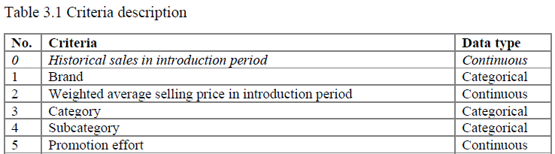
- Figure number and caption should be put under the figure. Example:
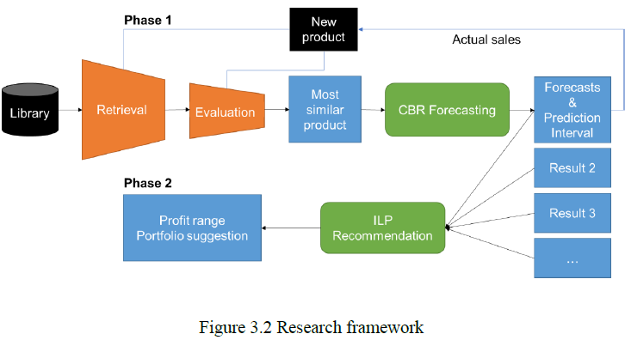
- Referential sources and comments should all be put under figures and tables.
- Texts inside tables or figures should be typed, not written.
- References:
- Please ensure that every reference cited in the text is present in the reference list (and vice versa). Any references cited in the abstract must be given in full.
- All references should be listed individually on a new page after the main text. The page numbers of the references should follow the main text. (See Appendix K)
- A citation software (EndNote, Mendeley, etc.) should be used for citation in the text by following the referencing style - the American Psychological Association (APA Style).
- References can be in any style or format as long as the style is consistent. Where applicable, author(s) name(s), journal title/book title, chapter title/article title, year of publication, volume number/book chapter, and the article number or pagination must be present.
- Example:
Citation in text: In-text citations are placed within sentences and paragraphs so that it is clear what information is being quoted or paraphrased and whose information is being cited.
- Works by a single author
The last name of the author and the year of publication are inserted in the text at the appropriate point.
…from theory on bounded rationality (Simon, 1945).
Simon (1945) proposed that…
- Works by two authors
When a work has two authors, always cite both names every time the reference occurs in the text and the year of publication.
…as has been shown (Leiter and Maslach, 1998).
Leiter and Maslach (1998) demonstrated…
- Works by multiple authors
When a work has three, four, or five authors, cite only the last name of the first author followed by "et al." (Latin for "and others") and the year of publication.
Kahneman et al. (1991) found…
References List: references should be arranged first alphabetically and then further sorted chronologically if necessary. More than one reference from the same author(s) in the same year must be identified by the letters 'a', 'b', 'c', etc., placed after the year of publication.
- Reference to a journal publication:
Van der Geer, J., Hanraads, J. A. J., & Lupton, R. A. (2010). The art of writing a scientific article. Journal of Scientific Communications, 163, 51–59. https://doi.org/10.1016/j.sc.2010.00372.
- Reference to a book:
Strunk, W., Jr., & White, E. B. (2000). The elements of style (4th ed.). Longman (Chapter 4).
- Reference to a website:
Powertech Systems. (2015). Lithium-ion vs lead-acid cost analysis. Retrieved from http://www.powertechsystems.eu/home/tech-corner/lithium-ion-vs-lead-acid-cost-analysis/. Accessed January 6, 2016
- Reference to a dataset:
[dataset] Oguro, M., Imahiro, S., Saito, S., & Nakashizuka, T. (2015). Mortality data for Japanese oak wilt disease and surrounding forest compositions. Mendeley Data, v1. https://doi.org/10.17632/xwj98nb39r.1.
- Reference to a conference paper or poster presentation:
Engle, E.K., Cash, T.F., & Jarry, J.L. (2009, November). The Body Image Behaviours Inventory-3: Development and validation of the Body Image Compulsive Actions and Body Image Avoidance Scales. Poster session presented at the meeting of the Association for Behavioural and Cognitive Therapies, New York, NY.
- Reference to software:
Coon, E., Berndt, M., Jan, A., Svyatsky, D., Atchley, A., Kikinzon, E., Harp, D., Manzini, G., Shelef, E., Lipnikov, K., Garimella, R., Xu, C., Moulton, D., Karra, S., Painter, S., Jafarov, E., & Molins, S. (2020, March 25). Advanced Terrestrial Simulator (ATS) v0.88 (Version 0.88). Zenodo. https://doi.org/10.5281/zenodo.3727209.
- Assessment Scheme:
Assessment types | Assessment component | Percentage (%)
A1. Proposal Assessment | A1.1 Report | > 50%
 | A1.2 Presentation | > 50%
A2. Midterm assessment | A2.1 Midterm Report | > 50%
A3. Final assessment | A3.1 Advisor Evaluation | 20%
 | A3.2 Reviewer Evaluation | 20%
 | A3.3 Committee Evaluation | 60%
- Regulations
- No cheating.
- Workload: cover all chapters.
- Attendance:
- Before Midway.
- After Midway.
- Teamwork Thesis:
- Indicating the team member who is responsible for each section.
- Adding a table for summarizing Task allocations and Score distributions.
- Highlighting the special contribution of each member make it easier for the evaluation from advisors, reviewers, and committee members.
VIETNAM NATIONAL UNIVERSITY – HO CHI MINH CITY
INTERNATIONAL UNIVERSITY
SCHOOL OF INDUSTRIAL ENGINEERING AND MANAGEMENT

TITLE OF THE DISSERTATION

Submitted in partial fulfilment of the requirements for the Degree of Bachelor of Engineering in Logistics and Supply Chain Management

Student:
ID:
Thesis Advisor:

Ho Chi Minh City, Vietnam
Month Year

VIETNAM NATIONAL UNIVERSITY – HO CHI MINH CITY
INTERNATIONAL UNIVERSITY
SCHOOL OF INDUSTRIAL ENGINEERING AND MANAGEMENT

TITLE OF THE DISSERTATION

Submitted in partial fulfillment of the requirements for the Degree of Bachelor of Engineering in Logistics and Supply Chain Management/

Student:
ID:
Thesis Advisor:

Ho Chi Minh City, Vietnam
Month Year

TITLE OF THE DISSERTATION

By

Name

Submitted in partial fulfillment of the requirements for the Degree of Bachelor of Engineering in Logistics and Supply Chain Management
International University, Ho Chi Minh City
Month Year

Signature of Student:

Certified by
Thesis Advisor

Approved by
Dean of IEM school

Abstract

Begin writing here…
Content:
- Briefly introduce the study topic, state the research problem.
- Provide the research methodology, design, procedures, and result from analysis.
- State the conclusions to include both the potential implications of the results on and the recommendations for future research and practice.
- References should be avoided, but if essential, then cite the author(s) and year(s).
- Also, non-standard or uncommon abbreviations should be avoided, but if essential they must be defined at their first mention in the abstract itself.
Keywords:
Immediately after the abstract, provide a maximum of 5 keywords, using American spelling and avoiding general and plural terms and multiple concepts (avoid, for example, 'and', 'of').

Acknowledgements
Begin writing here…
Table of Contents
Abstract i
Acknowledgement ii
Table of Contents iii
List of Tables iv
List of Figures v
List of Abbreviations vi
List of Symbols vii
Chapter 1: INTRODUCTION 1
  - Background........................................................................................................................1
  - Problem Statement.............................................................................................................1
1.3. Objectives of the Study.....................................................................................................1
1.4. Scope and Limitation...................................................................................................1
Chapter 2: RELATED WORKS 2
2.1. Overview 2
2.2. Literature Review 2
2.3. Key References/Candidate Solution Methods 2
Chapter 3: METHODOLOGY 3
3.1. Approaches Comparison and Selection 3
3.2. Proposed System Design/ Proposed Solution Approach 3
Chapter 4: SOLUTION DEVELOPMENT 4
4.1. Model/ Prototype Solution 4
4.2. Solution Development 4
Chapter 5: RESULT ANALYSIS 5
5.1. Experimental Design 5
5.2. Result Illustration and Explanation 5
5.3. Result Analysis 5
Chapter 6: CONCLUSIONS 6
6.1. Results Discussion and Implication 6
6.2. Recommendations for Future Research 6
References 7
Appendices 8
Appendix A XXX 8
Appendix B XXX 9

List of Tables

Begin a list of tables here…

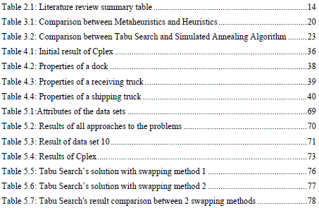
As Example:

List of Figures

Begin list of figures here…

As Example:
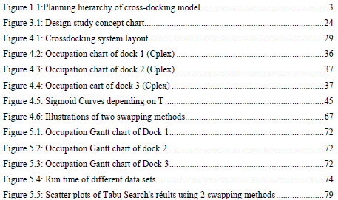

List of Abbreviations

Begin list of abbreviations here…

As Example:
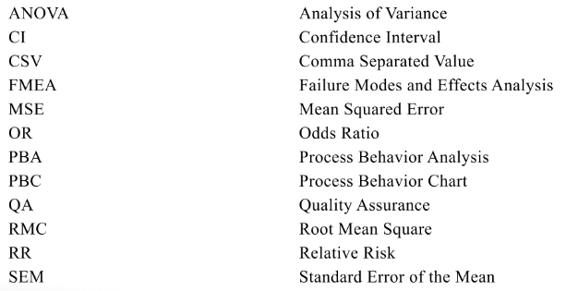
List of Symbols

Begin list of symbols here…

As Example:
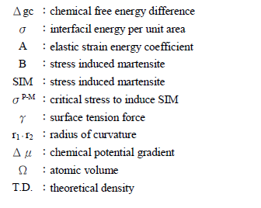

Chapter 1: INTRODUCTION

Begin writing here…

  - Background: Why study this topic?

  - Problem Statement – The Need for Study:
- Identify the problem or the gap needed to fill in the case.
- What needs to solve or achieve?

  - Objectives of Study:
- Who will benefit from the results of this study?
- What are expected outputs and/or applications? What are expected scientific contributions, if any?
- Design requirements.

  - Scope and Limitation:
- The scope of the study refers to the boundaries within which your research will be performed.
- To define the scope of the study, you must be clear on the research parameters that you will and won’t consider. These parameters usually consist of the sample size, the duration, inclusion and exclusion criteria, the methodology, and any geographical or monetary constraints.
- The sources of the data set? What kind of data? Time to collect the data? e.g. time frame of the data, and primary assumptions of your model, if any.
- Specify some practical constraints.
- Limitations refer to these constraints to the study that are beyond your control but that may influence the data. Limitations may emerge at any time during your study.

Chapter 2: RELATED WORKS

Begin writing here…

  - Overview:
- Theoretical foundations.
- Or Introduction to the case-studied company.

  - Literature Review:
- Investigate current development approaches in the literature related to the study.
- Summarize and classify the existing approaches, and select key references.
- Analyze the similarity and differences between key references and the thesis.
- Design concepts consideration.
- Note that this subsection includes the references cited and discussed in the thesis. The minimum number of references is 10 documents. It requires that at least 50% of the cited documents have been published within the last 5 years.

  - Key references/ Candidate Solution Methods
- A detailed description of potential approaches is to be considered.

Chapter 3: METHODOLOGY

Begin writing here…

  - Approaches Comparison and Selection:
- Summarize the advantages and disadvantages of the considered approaches.
- Conduct qualitative and/or quantitative comparisons to select the final approach.

  - Proposed System Design or Proposed Solution Approach:
- From the selected approach, develop the structure of the proposed system (inputs, process, outputs) or details of the proposed solution approach.
- Conceptual design description:
  - Conceptual design is a framework for establishing the underlying idea behind a design and a plan for how it will be expressed visually.
  - It is related to the term “concept art”, which is an illustration that conveys the vision for how the final product/system might take form.
  - Note that this is the process of the system you designed, NOT the procedure of doing the thesis.
- Analyze and justify the techniques to be used.

Chapter 4: SOLUTION DEVELOPMENT

Begin writing here…

  - Model or Prototype Solution:
- Identify parameters, components of the system and related assumptions & constraints.
- Construction phase: formulate a Mathematical Model or a Prototype Solution for the system.

  - Solution Development:
- Construct a small numerical solution.
- Implementation of the proposed solution or model.
- Investigate all possible solutions and develop an improved solution.
- Compare alternative solutions subject to feasibility constraints (economic factors, environmental and social) and the appropriate standards: ISO, OSHA, ANSI, HACPP, TCVN, etc.

Chapter 5: RESULT ANALYSIS

Begin writing here…
  - Experimental Design
- Describe the process of planning an experiment to test a hypothesis.
- Plan experiments in advance so that your results are both objective and valid.

  - Result Illustration and Explanation:
- Describe the obtained results of the model or prototype’s solution.
- Conduct validation (experiments, measure of prototype outputs,…) and analyze the efficiency of the obtained results/ prototype/design/ model/solution.
- Ex: In machine learning, model validation is the set of processes and activities intended to verify that models are performing as expected. There are two ways to statistically validate a model: one can evaluate the model on the data the model was trained on, or one can evaluate it on an external test set

  - Result Analysis:
- Conduct Sensitivity Analysis.
  - The purpose of running a sensitivity analysis is to determine the relative influence of parameters, initial conditions, and alternative assumptions on model output.
  - The process is iterative, providing feedback that can improve the model. A sensitivity analysis compares response variables from multiple model runs.
  - In each of the comparison runs all parameters are held constant except for the parameter being examined.
  - When a model parameter is observed to exert undue influence on the output which does not reflect reality, the characterization of the model must be re-evaluated.
- Analyze and evaluate the environmental, social, and economic impacts. Note that this analysis should be associated with the framework of the thesis topic, thus students should not write this part in general only. For example, the topic of transportation optimization will create what impacts specifically.
- Recommended final design solution.

Chapter 6: CONCLUSIONS

Begin writing here…

  - Results Discussion and Implication
- Provide a strong, concise conclusion to include a summary of the study, the problem addressed, and the importance of the study.
- Present the results in the context of the study by describing the extent to which they address the study problem and contribute to the existing literature and framework described in the literature review.
- Identify the most significant implications and consequences of the dissertation (whether positive and/or negative) to society/desired societal outcomes and distinguish probable from improbable implications.

  - Recommendations for Future Research
- Based on the framework, findings, and implications, explain what future researchers might do to learn from and build upon this study.
- Discuss how future researchers can improve upon this study, given its limitations.

References

Author, A., & Author, B. (year). Article title. Journal title, X(X), xxx-xxx. https://doi.org/xxxxx

As Example:

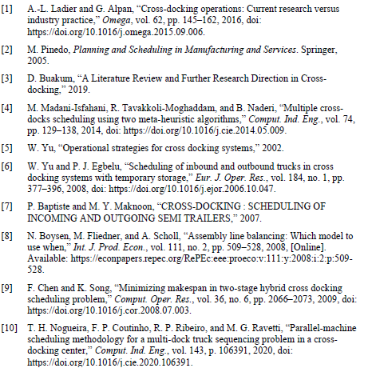

Appendix A
XXX
Insert Appendix A content here…

Appendix B
XXX
Insert Appendix B content here…

